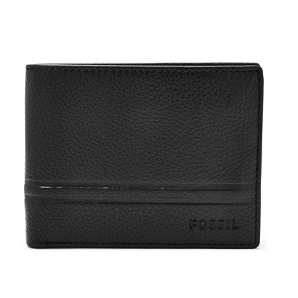

WILDER FLIP ID BIFOLD

PRODUCT DETAILS

**Silhouette: Bifold with Flip ID**

**Exterior Material: Leather**

**Interior Details: 6 Credit Card Slots, 1 Billfold Pocket, 2 Slide Pockets and 2 ID Windows**

**Measurements: 4.38"L x 0.75"W x 3.38"H**

**Warranty: 1 Year Limited**